Springfield Financial Services Levens 10
September 15th 2019

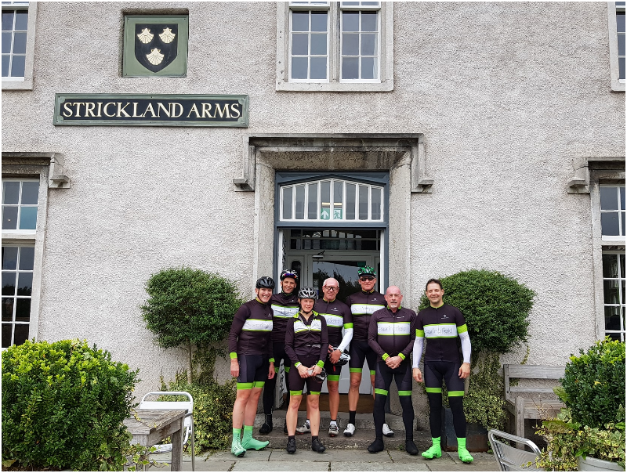
A big thankyou from all of our merry band of cyclists for participating in our event and making a successful and enjoyable day. The choice of HQ seemed rather popular too.
Everyone competing and helping at the event was a winner but fastest female on the day was Anna Turvey – Drag2Zero with 20:10 and an overall 7th place in the event behind overall winner Phil Jones – Transition Race Team with 19:09.
We hope to see you all again at one of the team’s events next season.

